**Submission Instructions:**

Your submission for this activity should be a Word document that includes the following screenshots, each labeled for the step that the screenshot represents:

1. Provide a screenshot of your Docker desktop to show that you successfully created the NiFi and Cassandra *containers* in the Docker network.

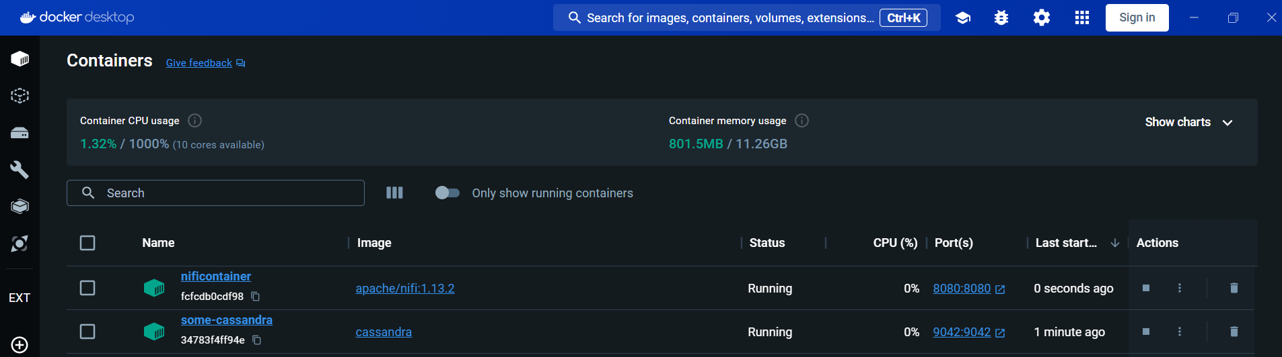

1. Provide a screenshot of the bash window in the Cassandra *server* to show that you successfully ran the cqlsh command.

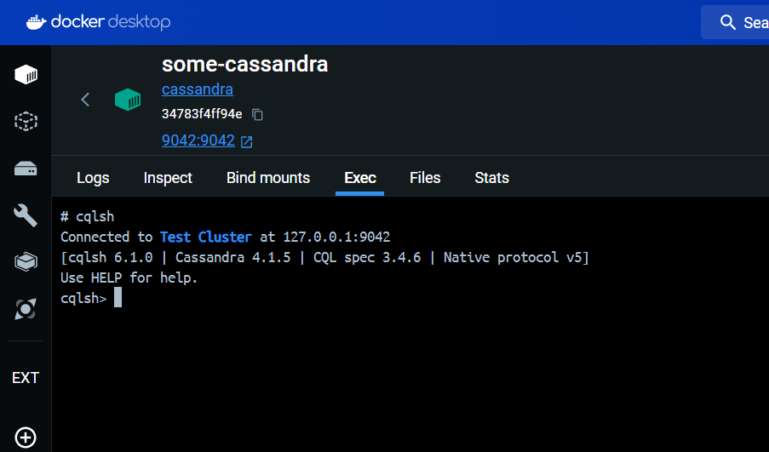

1. Provide a screenshot of the Terminal window to show that “Peter Parker” was inserted correctly into the Cassandra data table.

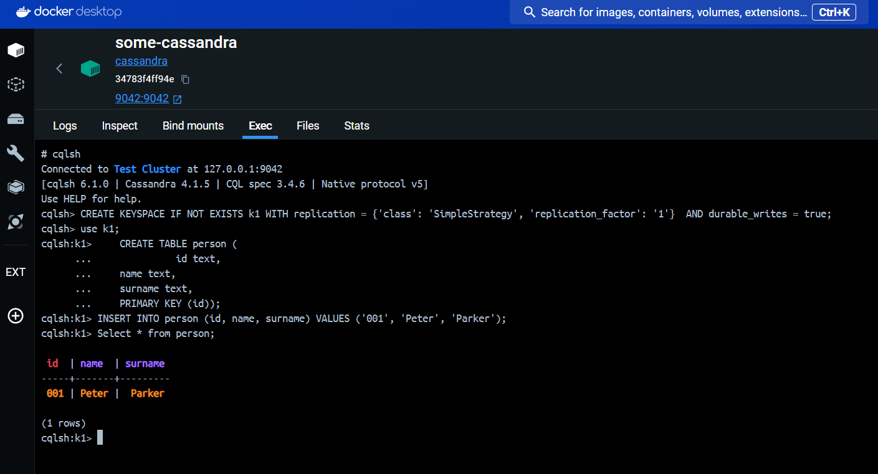

1. Provide a screenshot to show that you successfully started the NiFi UI.

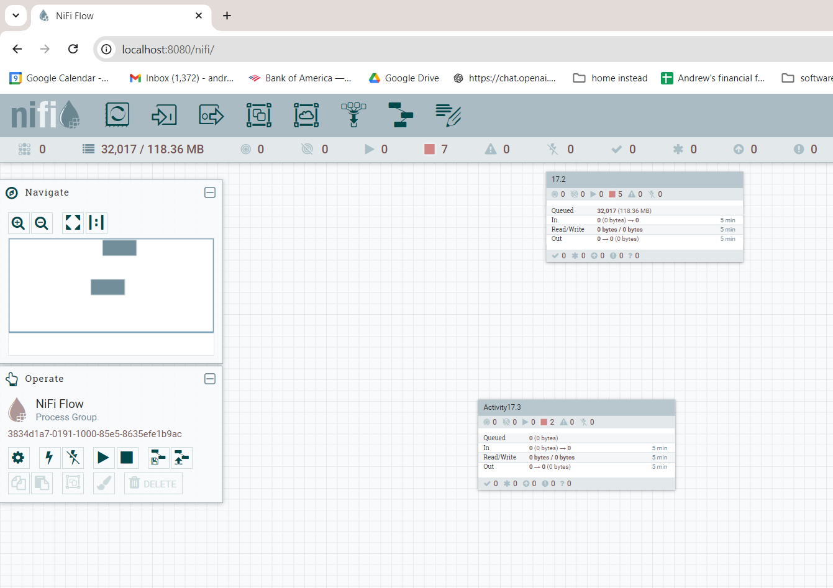

1. Provide a screenshot to show that you successfully created the Cassandra-test process group.

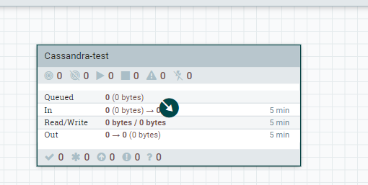

1. Provide a screenshot to show that you correctly set the fields of the PROPERTIES tab.

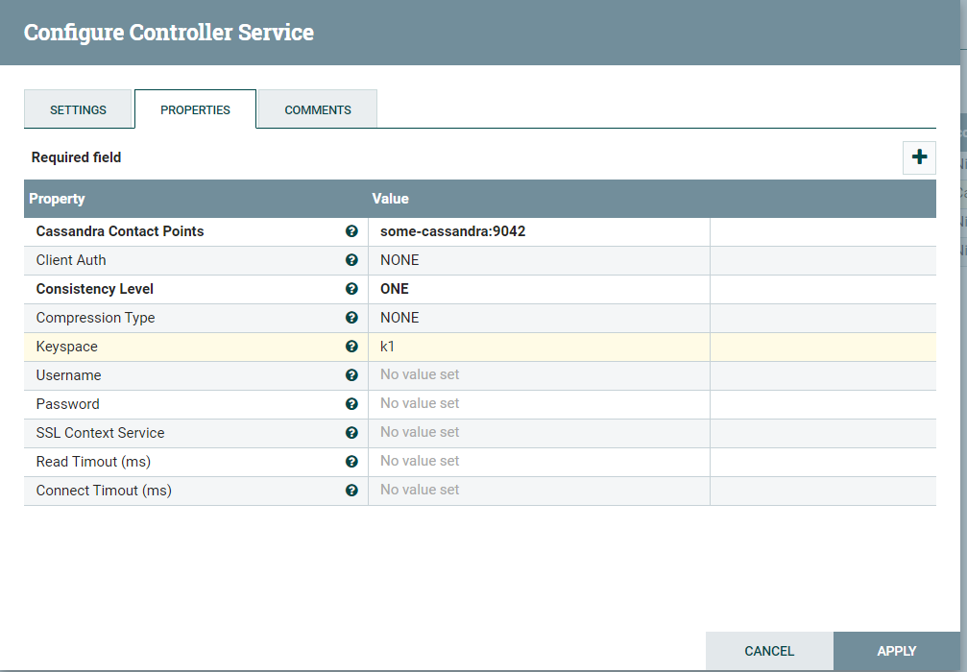

1. Provide a screenshot to show that the CassandraSessionProvider *controller* service was successfully activated.

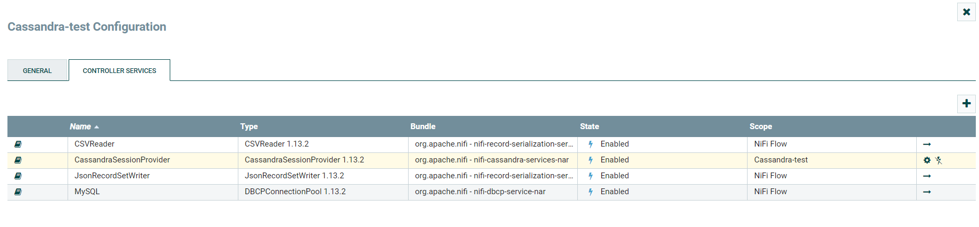

1. Provide a screenshot to show that you correctly set the fields of the PROPERTIES tab.

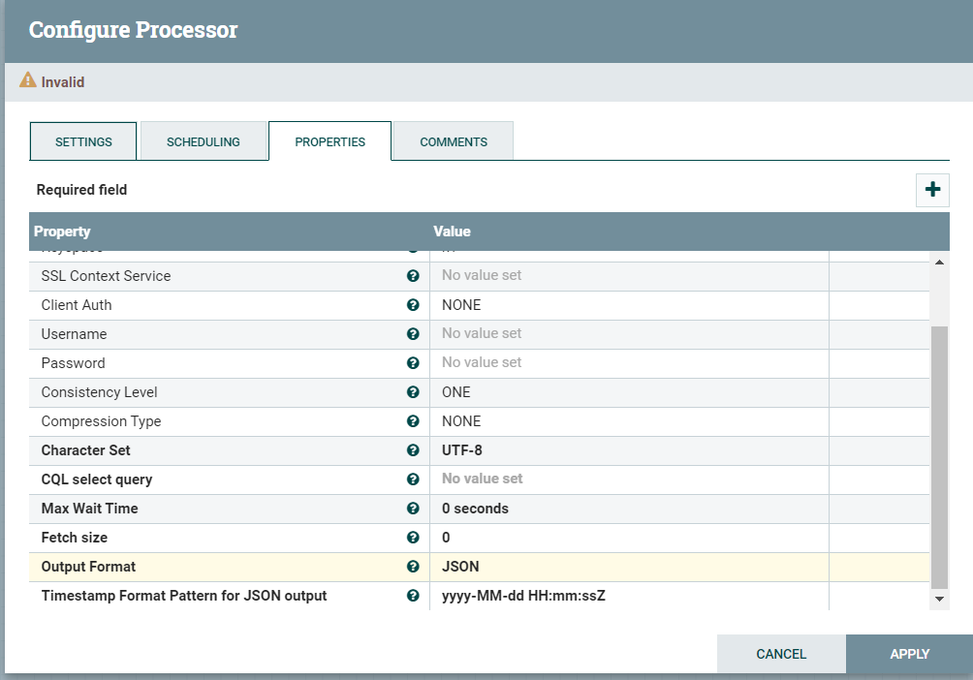

1. Provide a screenshot to show that the person table is empty within MySQL Workbench.

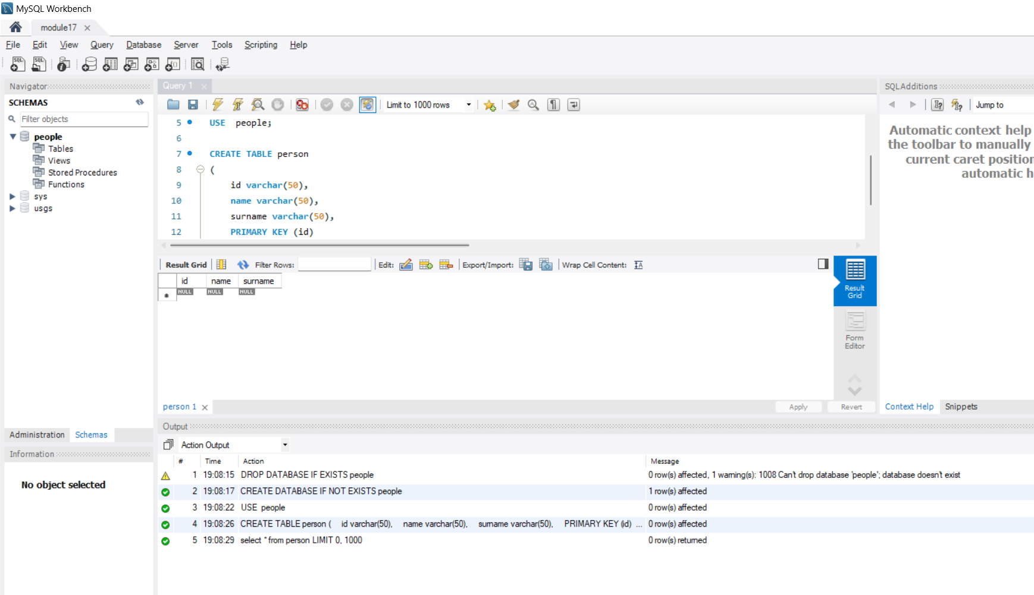

1. Provide a screenshot of the DBCPConnectionPool *connector* service activated within the NiFi UI.

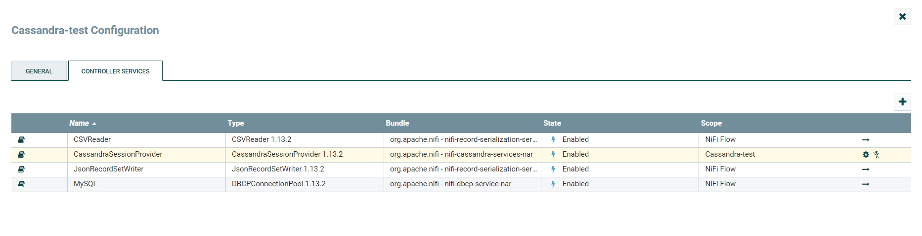

1. Provide two screenshots. The first screenshot should show that you set the values in the SETTINGS tab correctly. The second screenshot should show that you updated the scheduling time in the PROPERTIES tab correctly.

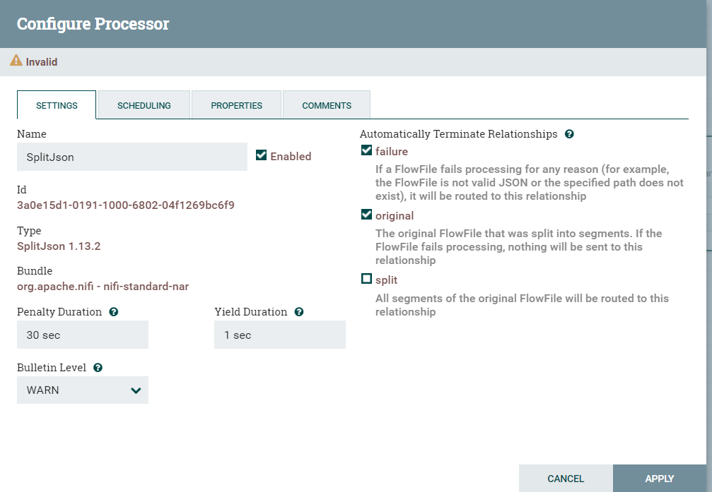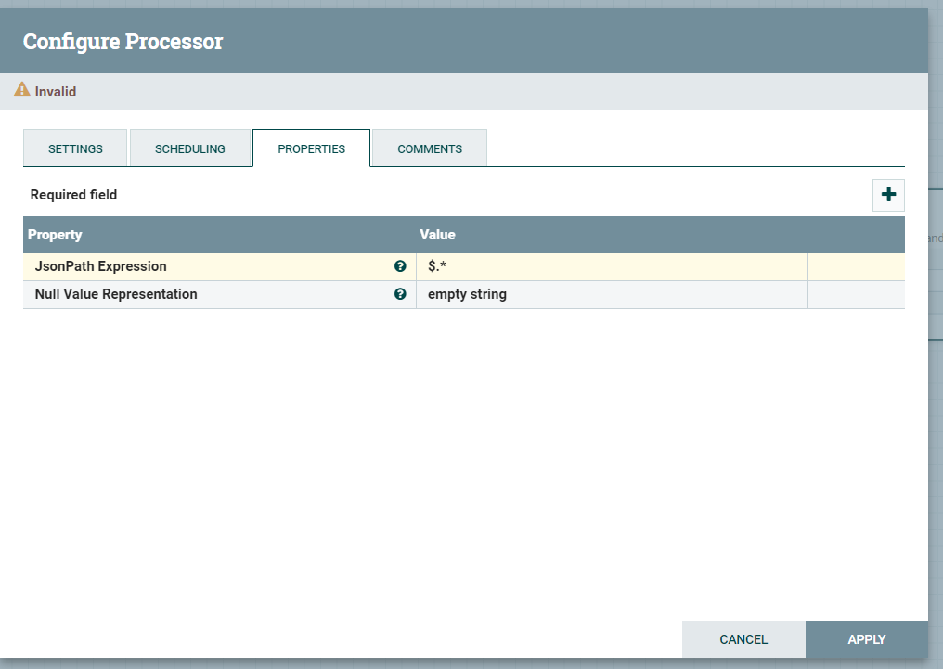

1. Provide a screenshot to show that you configured the PROPERTIES tab for the ConvertJSONToSQL *processor* correctly.

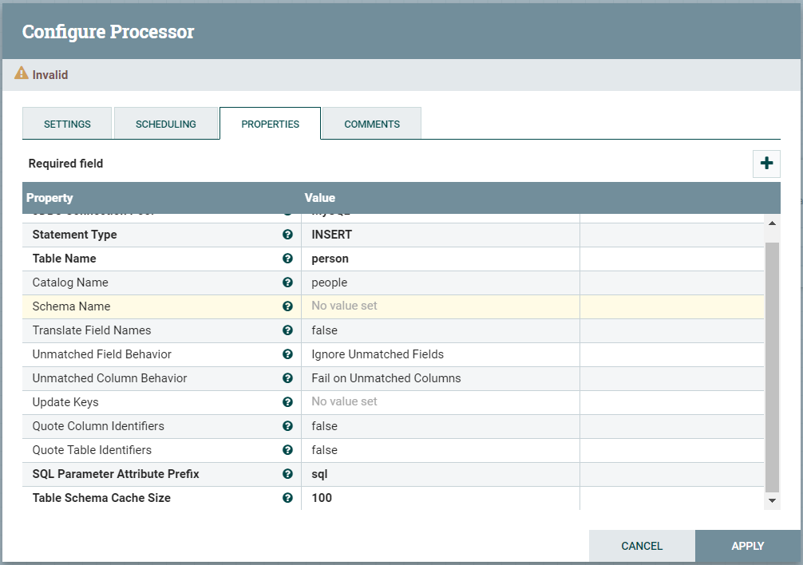

1. Provide a screenshot of the connected QueryCassandra, SplitJSON, and ConvertJSONToSQL *processors*.

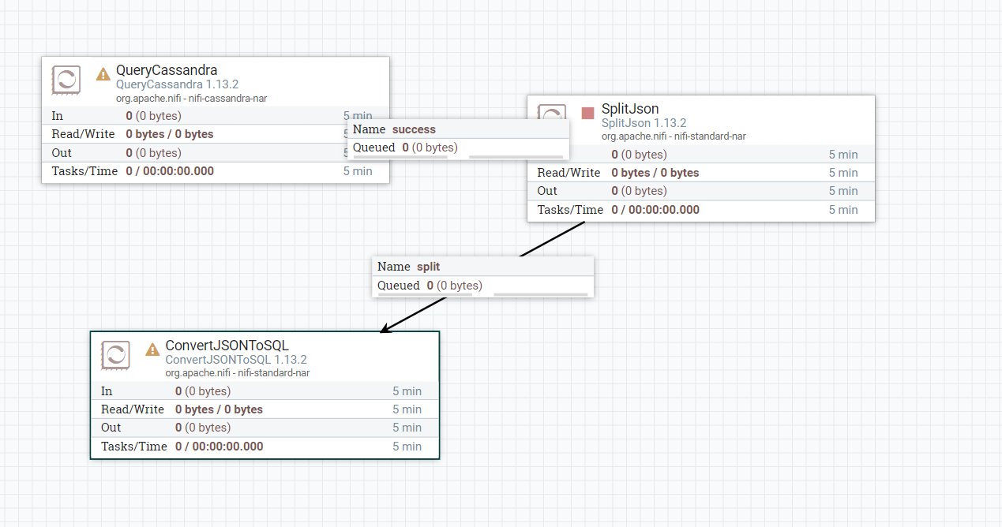

1. Provide a screenshot to show that all four *processors* (QueryCassandra, SplitJSON, ConvertJSONToSQL, and PutSQL) are connected.

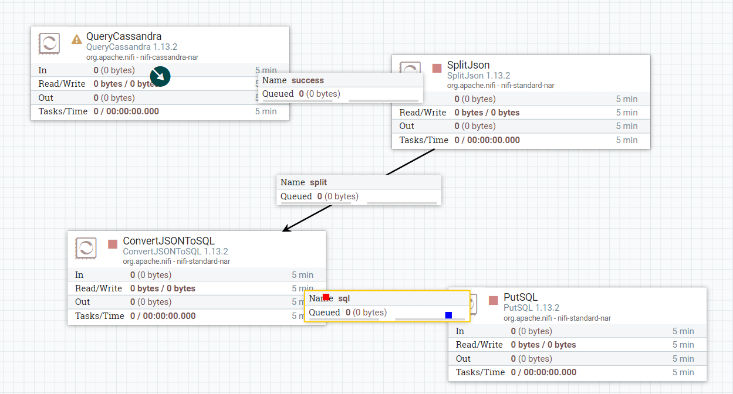

1. Provide a screenshot to show the data was added to your MySQL database correctly.

